VIT running results（2.27）
Evaluation without augmented data
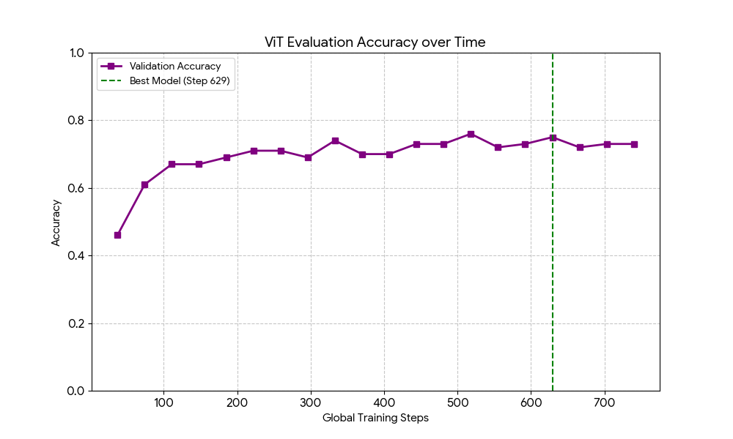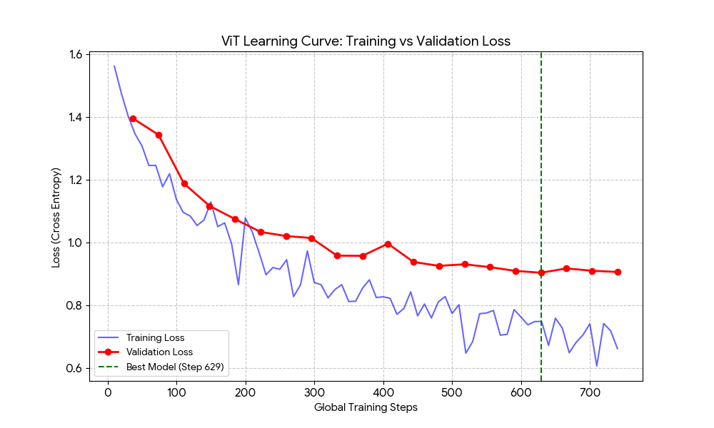
Learning Curve (Loss)
- Observations: Both the Training Loss (blue) and Validation Loss (red) decrease steadily together.
- The Overfit Test: In an overfitted model, the blue line would continue to drop toward zero while the red line would shoot upward. Here, the red line remains stable and follows the blue line closely.
- The "Sweet Spot": The green dashed line marks Step 629 (Epoch 17). You can see that after this point, the Validation Loss stopped improving and started to fluctuate slightly. The Early Stopping was triggered perfectly to save the model at its peak

Validation Accuracy Curve
This shows how the model's "intelligence" grew over the 20 epochs.
- Observations: The accuracy starts low (~46%) and climbs rapidly before plateauing around 75%.
- Conclusion: The plateau is very flat, which means the model didn't start "memorizing" the training set at the end. It reached a natural limit of what it could learn from the experimental dataset features.

Summary
- Stable Gap: The gap between training loss and validation loss is small and consistent.
- Generalization: Because the validation loss (data the model never "learned" from) stayed low, we can trust that the model will perform similarly on your Test Set.
- Automatic Protection: Even though you ran 20 epochs, the script was smart enough to ignore the last 3 epochs (where error might have started to creep in) and kept the version from Epoch 17.

Classification result:
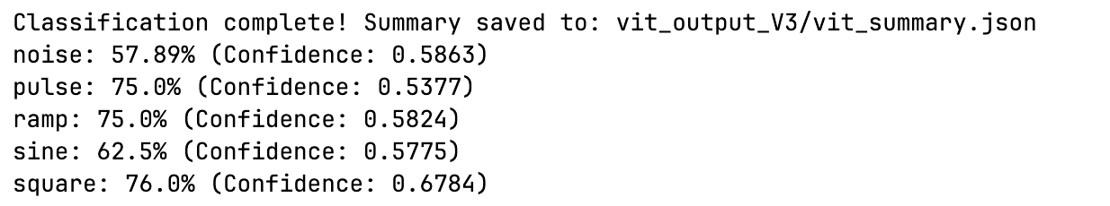

Evaluation with augmented data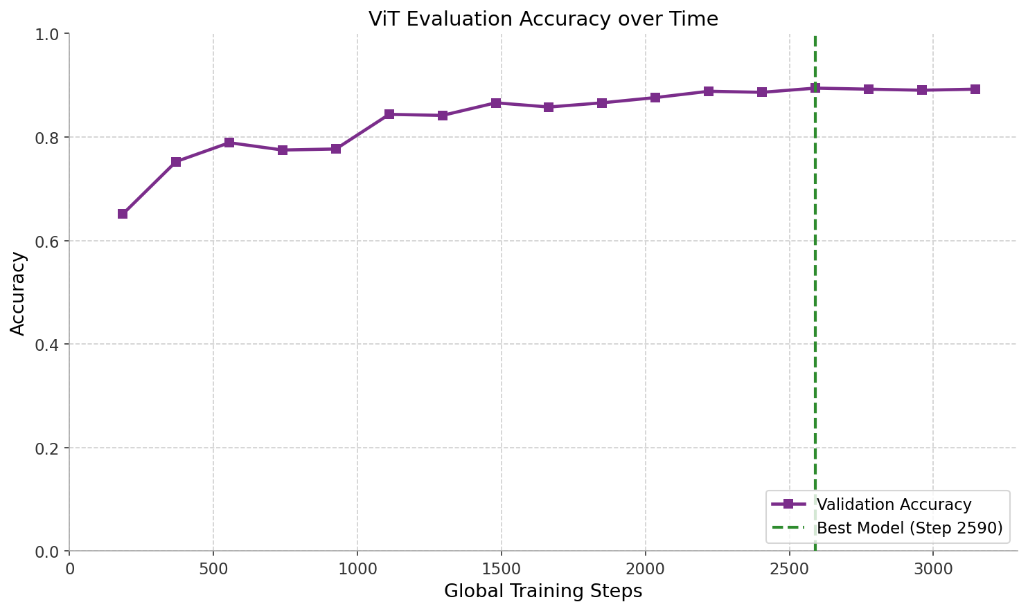
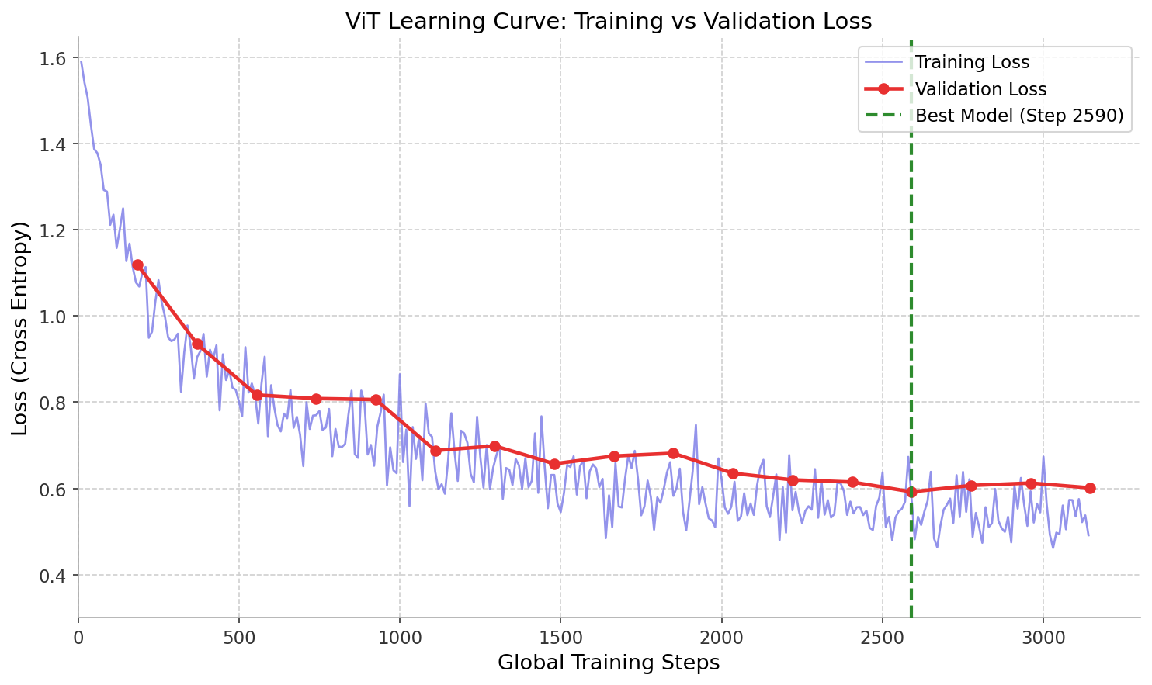
Learning Curve (Loss)
Both training loss (blue) and validation loss (red) decrease steadily and converge closely together throughout training — a very healthy sign. The gap between them stays small and never diverges, which means the model is generalizing well and not memorizing the training data. The green dashed line marks Step 2590 (Epoch 14), where the best checkpoint was saved. After that point, val loss stopped improving and early stopping kicked in.

Validation Accuracy
Accuracy climbs rapidly from ~65% in the early steps to a plateau around 89–89.5%. The curve is smooth and never drops sharply after the best step — it just flattens slightly. This plateau shape is ideal: it shows the model reached the natural limit of what it could learn from the augmented dataset rather than overfitting.

Comparison with non-augmented run:
 | Non-augmented | Augmented (V3)
Best Val Accuracy | ~75% | 89.5%
Final Val Accuracy | ~73% | 89.2%
Best Step | 629 | 2590

Model Well-Fit because:
- Train loss and val loss converge smoothly to a similar range (~0.49 vs ~0.59)
- The best checkpoint at Step 2590 / Epoch 14 was caught perfectly by early stopping before any real degradation began
- The ~0.10 gap between train loss and val loss at the end is normal and healthy — a perfect zero gap would actually be suspicious
Classification result:
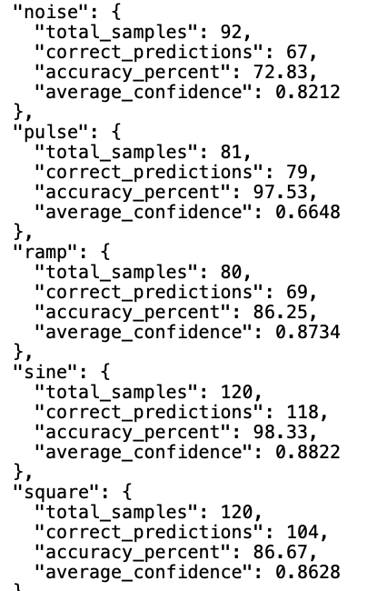
Same result different visualize analysis (with augmented data)
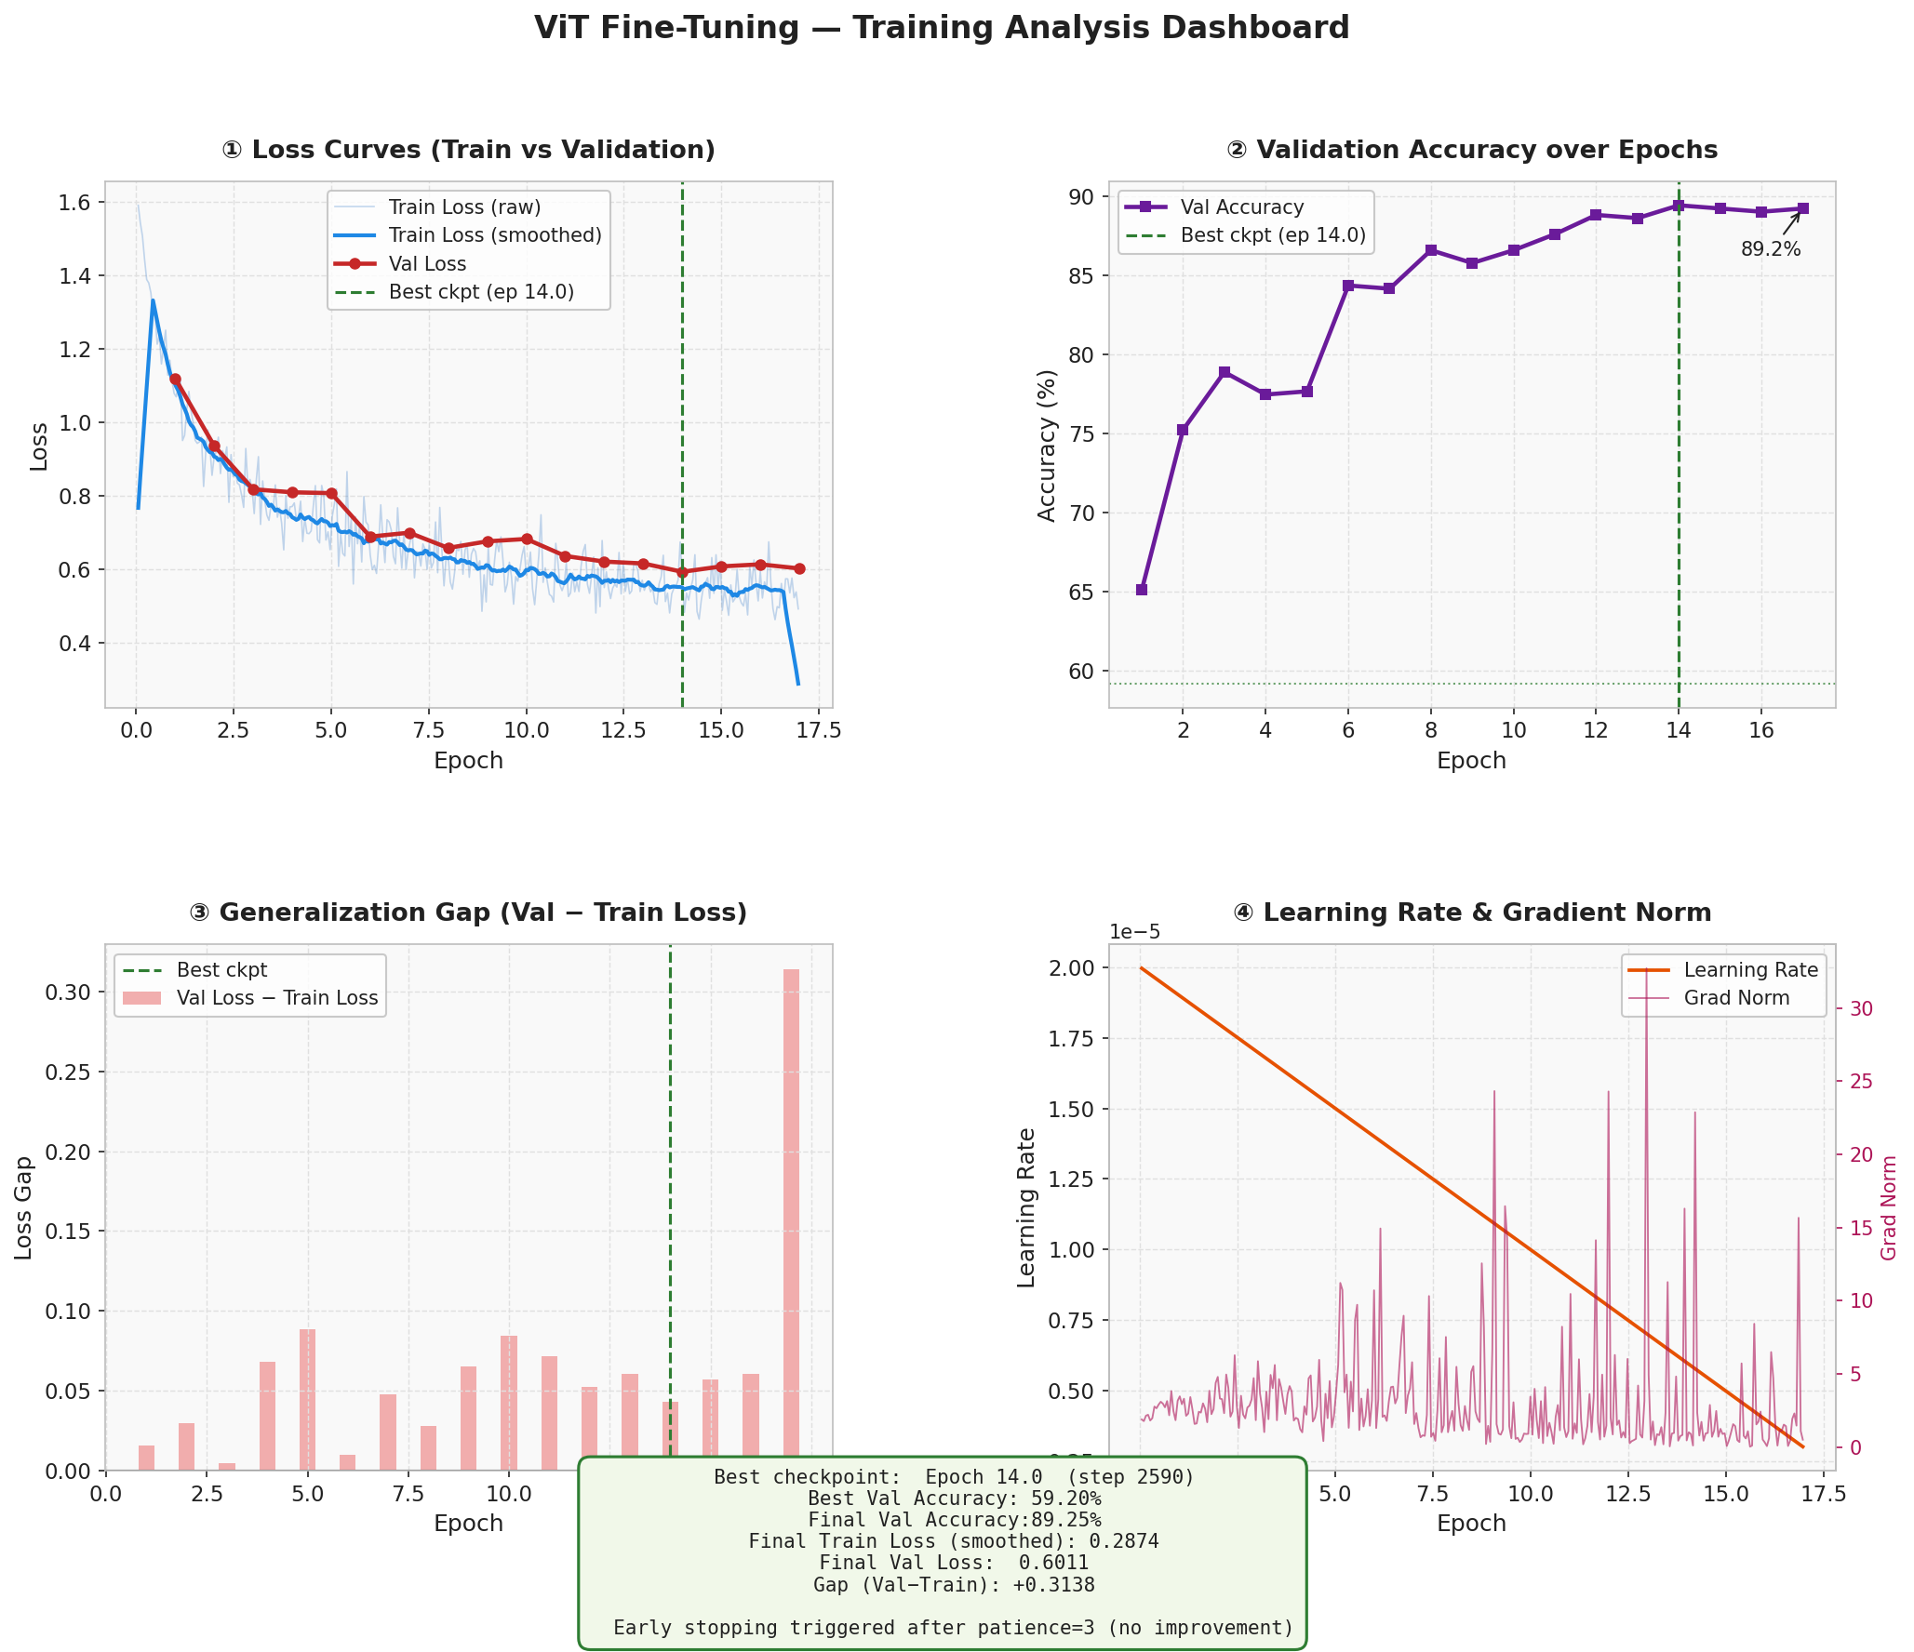
Looking at plot ③ (Generalization Gap):
- The gap between val loss and train loss is positive but small and stable — the model isn't catastrophically overfitting.
- However, val loss stopped improving after epoch 14 (best checkpoint: step 2590, ~89.45% acc), while training loss kept falling slightly. This is the classic early sign of overfitting onset.
- Early stopping correctly kicked in after 3 patience epochs with no val loss improvement.

Is it a good fit? YES — the model is in a good zone
Epoch | Val Loss | Val Accuracy
1 | 1.119 | 65.1%
8 | 0.657 | 86.6%
14 | 0.592 | 89.5% ← Best
17 | 0.601 | 89.2%
The best checkpoint at epoch 14 / step 2590 is the one to use. The drop after that is minor, so you're not severely overfit — but you are at the sweet spot.

A few things to watch:
- Grad norm spikes (plot ④) occasionally spike high (e.g., ~15 at epoch 16.8). These are harmless here but could destabilize training if they were more frequent — gradient clipping is worth keeping.
- The linear LR decay down to ~3×10⁻⁶ seems appropriate and helped smooth convergence.
- If you want to push beyond 89.5%, consider: longer warmup, label smoothing, or slightly more aggressive augmentation.

Result Comparison:
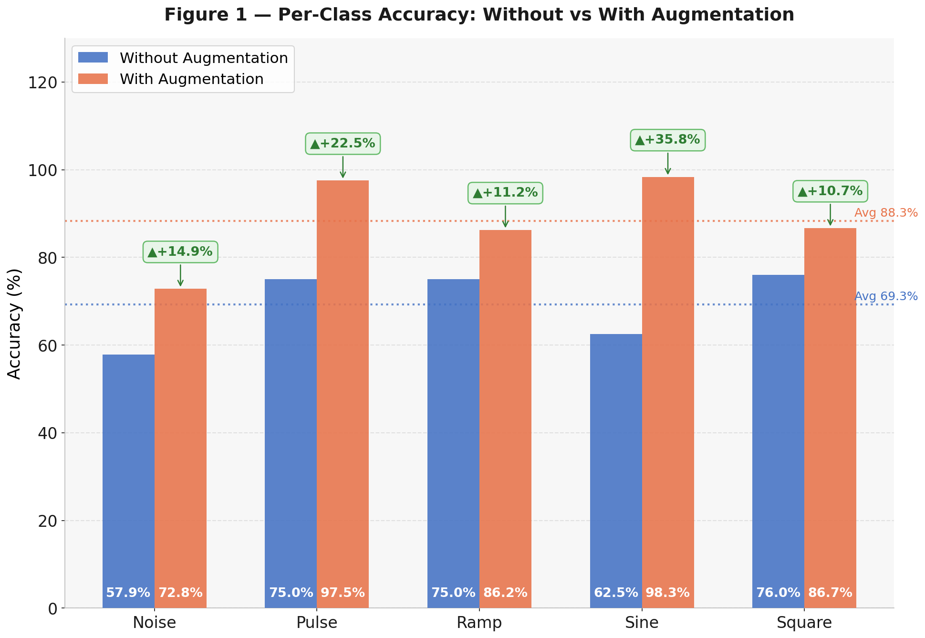
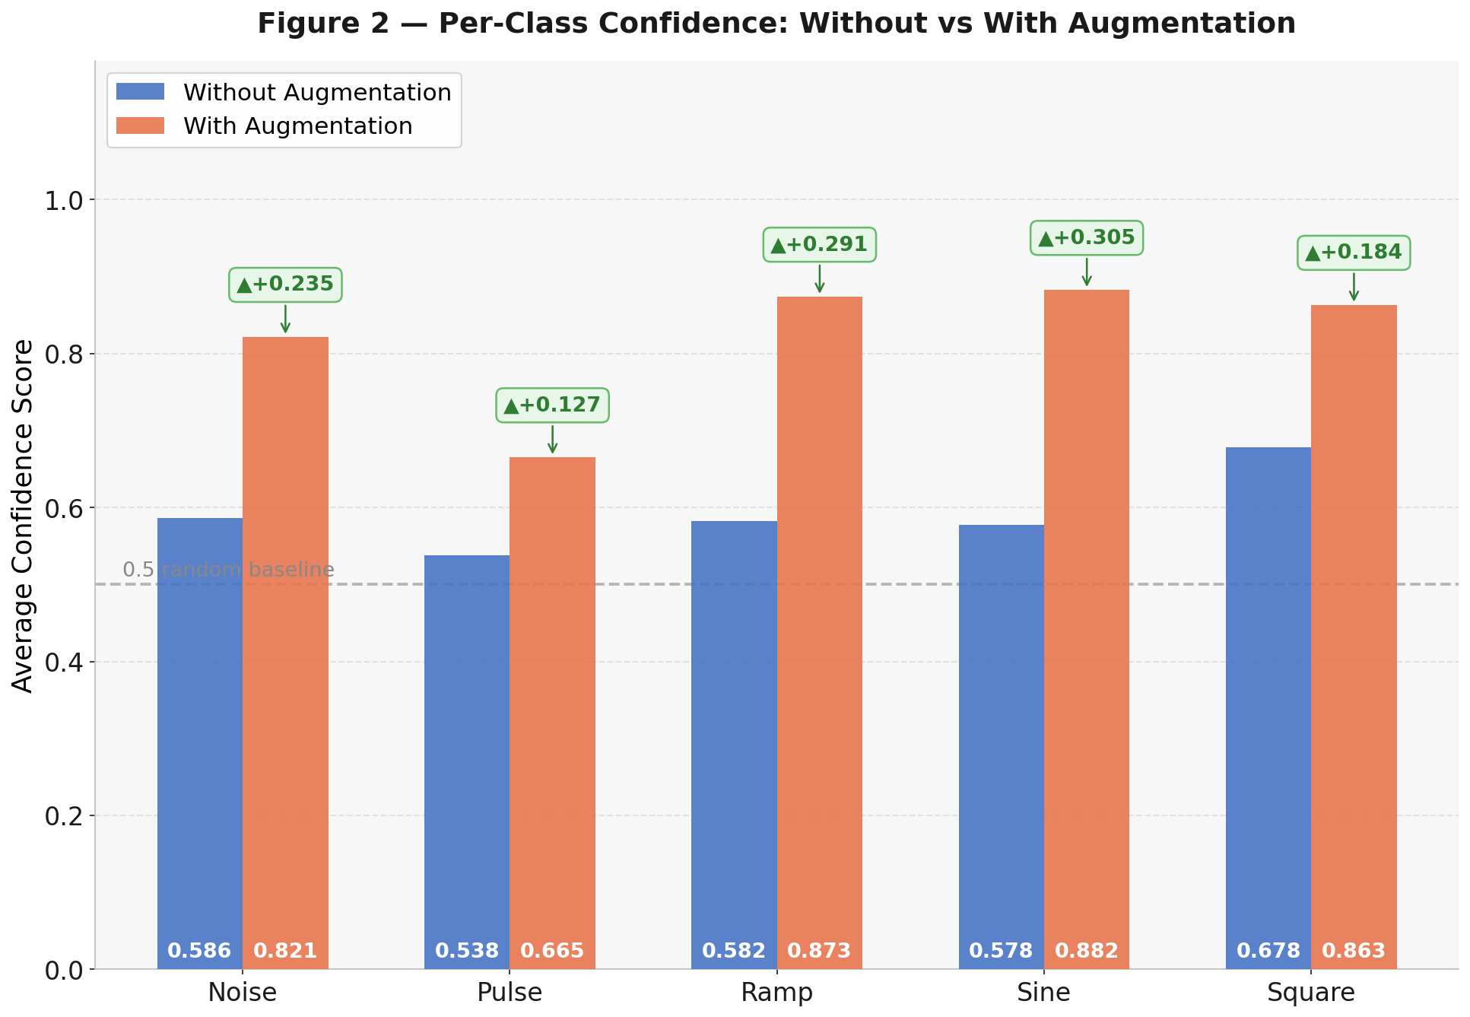
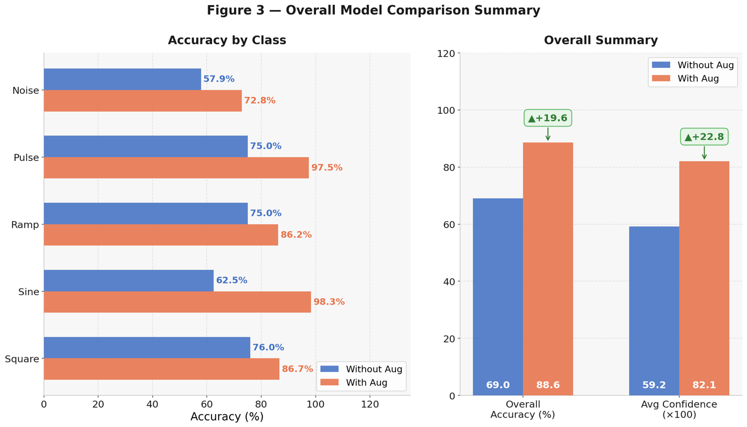
Overall Summary gives the big picture at a glance: overall accuracy jumped from 69.0% → 88.6% (+19.6%) and average confidence from 59.3 → 82.1 (+22.8 pts). The horizontal bar on the left also lets you visually rank which classes still need the most work (Noise at 72.8% is clearly the remaining weak spot).

